**HW 03: Creating Graphical User Interfaces (GUI) in Java**

**Due 8:00 AM Friday, Oct 23, 2020**

**Part I: Hand-coded Java GUI Tutorial**

**Step 1) Create a new window**

Using Eclipse, Create a new Java Project, Add a new class and name it GuiTest with a main method, then type the following code:

01. **import** javax.swing.*;

02. **public** **class** GuiTest{

03. **public** **static** **void** main(String args[]){

04. JFrame frame = **new** JFrame("My First GUI");

05. frame.setDefaultCloseOperation(JFrame.EXIT_ON_CLOSE);

06. frame.setSize(300,300);

07. frame.setVisible(**true**);

08. }

09. }

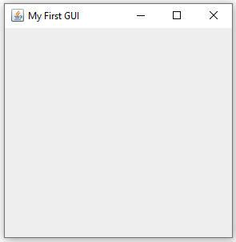**Step 2) Save, Compile and Run the code.**

Verify that you get a square window the tile “My First GUI”, a minimize button, a maximize button and a close button.

**Observe**:

* The program you just wrote consists of a simple class with a main method which was able to create a graphical window because it created an object of type JFrame.
* JFrame is a class that was coded to draw a window; nevertheless it is a bona fide java class with method, properties, constructor, etc.

**Answer the following questions:**

* What does the constructor of JFrame look like? (Write the formal method signature of the constructor that was used.

JFrame();

1. What is the parameter of this specific constructor used for?

The parameter of this specific constructor is used to display the name tag or title of the JFrame.

1. What is the nature of JFrame.EXIT_ON_CLOSE? (is it a method, field,…). Write down its formal declaration line

JFrame.EXIT_ON_CLOSE is a field that allow you to exit the application, and its formal declaration is

frame.setDefaultCloseOperation(JFrame.EXIT_ON_CLOSE);

* Find out which method of JFrame changes the cursor displayed when the mouse is over the window. Write down the line you would use to change the cursor to an hourglass.

Cursor cursor = **new** Cursor(Cursor.***WAIT_CURSOR***);

frame.setCursor(cursor);

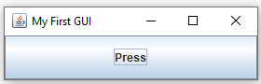**Step 3) Add a Button to the window:**

Add the following two lines after the declaration and initialization of frame:

JButton button1 = **new** JButton("Press");

frame.getContentPane().add(button1);

**Step 4) Execute the code. You will get a big button**

Verify that a button labeled “Press” occupies the whole window.

**Observe**:

Adding a button consists of creating an object of type JButton, then adding that object to the content pane.

* We did not specify the size of the button, so it filled the window.
* Pressing the button does nothing so far.

**Answer the following questions:**

On a new line below the declaration of button1, type button1 then press the dot . key to ask Eclipse to display the public members of the class JButton, then choose the method that sets the **text** of the button. Write the line of code required to change the text of the button to “Press Me”

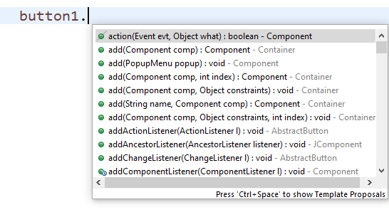

Answer: button1.setText(“Press me “);

1. Type button then press the dot . key and choose the method that sets the **tooltip** of the button. Write the line of code required to change the tooltip of the button to “Press me and watch what happens”

Answer: button1.setToulTipText(“Press me and watch what happens”);

**Step 5) Add another button to the same window:**

Add the following two lines before the frame.setVisible line :

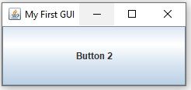JButton button2 = **new** JButton("Button 2");

frame.getContentPane().add(button2);

**Step 6) Save, Compile and Run the code.**

**Observe**:

* Adding a second button also filled the window and thus concealed the first button. We need a way to display both buttons.

**Step 7) Use a layout manager to display the two buttons.**

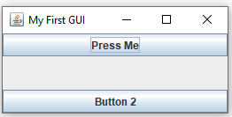Replace the two lines that add the buttons to the content pane by these two lines (you will need to add the right import statement):

frame.getContentPane().add(BorderLayout.NORTH,button1);

frame.getContentPane().add(BorderLayout.SOUTH,button2);

**Step 8) Save, Compile and Run the code.**

**Observe**:

* The two buttons are now bound to the top and bottom of the window.

**Answer the following questions:**

1. Change the position of the two buttons to make them bound to the left and right side of the window (west, east) instead of up and down (north, south). Write the two lines of code required to do so:

frame.getContentPane().add(BorderLayout.***WEST***,button1);

frame.getContentPane().add(BorderLayout.***EAST***,button2);

**A Note On Layout Managers**

A layout manager is used to *layout* (or *arrange*) the GUI components inside a container.

There are many layout managers, but the most frequently used are:

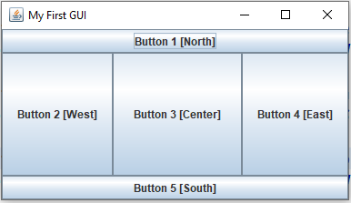**BorderLayout**

A BorderLayout places components in up to five areas: top, bottom, left, right, and center. It is the default layout manager for every JFrame

**FlowLayout**

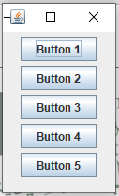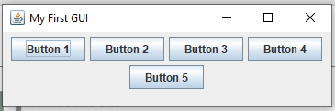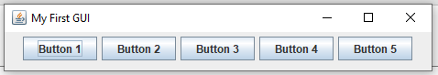FlowLayout is the default layout manager for every JPanel. It simply lays out components in sequence one after another, so depending on the size of the window you end up with the following:

**GridBagLayout**

It is the most sophisticated of all layouts. It aligns components by placing them within a grid of cells, allowing components to span more than one cell.

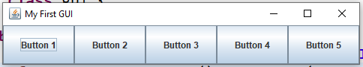

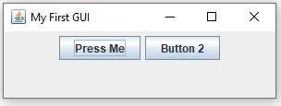**Step 8) Change the layout of the content pane to a FlowLayout**

* Set the layout of the content pane right before you add the buttons to it:

frame.getContentPane().setLayout(new FlowLayout());

**Step 9) Save, Compile and Run the code.**

**Observe**:

* The two buttons are now displayed from left to right starting from the top of the window.
* Change the order of the two lines that add the buttons and notice how the buttons have swapped positions

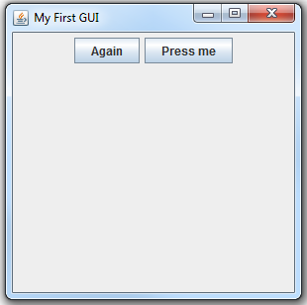**Step 10) Adding Event Handlers**

Two add event handlers you need to sub-class the JFrame class:

* Add a new class MyFrame to your project
* Make MyFrame inherit the JFrame (you’ll need to import javax.swing.JFrame)
* Declare two JButtons inside the class button1, and button2
* Create an overloaded constructor for MyFrame
* Since it inherits from JFrame which has an overloaded constructor that takes a string and displays it in the caption area of the window, make the overloaded constructor of MyFrame match that of JFrame
  + Inside this constructor pass the string to the constructor of the base class. Hint: constructor chaining, use the super keyword.
* Cut the code from your main method in GuiTest and paste it in the overloaded constructor you have just created.
* Here you no longer need to create an instance of JFrame because you are inside the constructor of a JFrame. Therefore, remove the line that declares an initializes a JFrame , then replace all references to frame with the this keyword.
* We need to reference button1 and button2 outside of the constructor that is why we declared them outside the constructor and gave them class-wide scope. Therefore, change the two declaration-and-initialization statements to initialization only statements (remove the JButton at the beginning of each line).
* Back in GUITest.main create an instance of MyFrame, that should be sufficient to see the window.
* Run your program and make sure you are seeing a new window. Note that pressing any of the two buttons does not generate any action yet.
* Now add the event handlers to the buttons:
* Make MyFrame implement the interface ActionListener (you’ll need to import java.awt.event.ActionListener)
* In the Eclipse editor, hover your mouse over the MyFrame and choose the “Add unimplemented methods” option. This will add the overrides you need to write (actionPerformed). The code inside the method will run any time a control generates an event.
* Add the following code to the method:

@Override

**public** **void** actionPerformed(ActionEvent e) {

JButton b = (JButton) e.getSource();

**if** (b==button1)

{

JOptionPane.*showConfirmDialog*(**this**, "You clicked Button1","Button Click Event Handler", JOptionPane.*PLAIN_MESSAGE*);

}**else** **if** (b==button2)

{

JOptionPane.*showConfirmDialog*(**this**, "You clicked Button2","Button Click Event Handler", JOptionPane.*PLAIN_MESSAGE*);

}

}

* Now make the buttons hook to the event handler of the JFrame:
* Add the following two lines to the end of the constructor

button1.addActionListener(**this**);

button2.addActionListener(**this**);

* Run your code and test it.

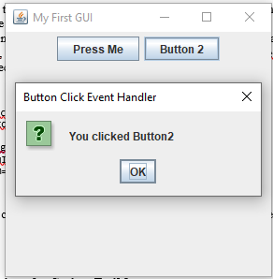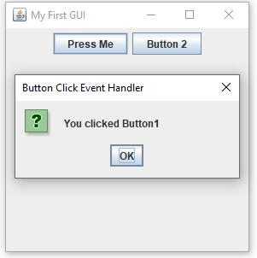

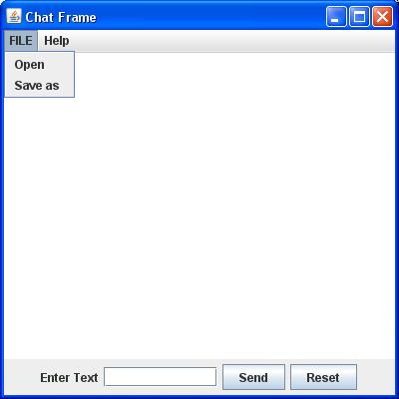**Part II: Creating your first GUI application**

**Write code (don’t use any GUI builders) to implement the following interface:**

* To add a menu, use the JMenuBar, JMenu, and JMenuItem classes

JMenuBar mb = **new** JMenuBar();

JMenu m1 = **new** JMenu("FILE");

mb.add(m1);

JMenuItem m11 = **new** JMenuItem("Open");

m1.add(m11);

this.setJMenuBar(mb);

* You need to add the event handlers to each JMenuItem (hint: they need to have class-wide scope)
* In the event handler you now need to know the type of object that triggered the event, prior to now we assumed it was always a JButton, but now it could be either a JButton or a JMenuItem. If it is a menu click then display the text of the menu item that was clicked.
* Hints:

**if** (e.getSource() **instanceof** JButton) {

JButton b = (JButton) e.getSource();

….

} **else** **if** (e.getSource() **instanceof** JMenuItem) {

JMenuItem m = (JMenuItem) e.getSource();

**if** (m==m11)

…

* Run your code and ensure the application is behaving as expected (test it).

**Submission Instructions:**

1. Create a private GitHub repository using your name
2. Upload your code and this filled-out document to the repository you’ve just created
3. share the repo with the professor and the TAs